UNIT NAME: Programming Languages
GROUP NO.: 25
GROUP MEMBERS: NAME REG NO.
Dorcas Eileen C026-01-0988/2025
Stacy Njeri C026-01-0939/2025
Eleanor Wangeci C026-01-0944/2025
TEST RESULTS
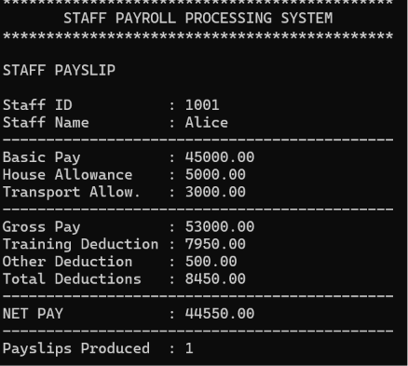
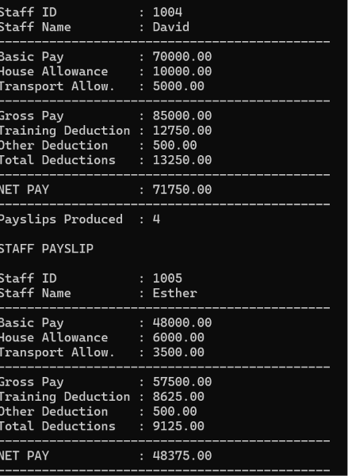
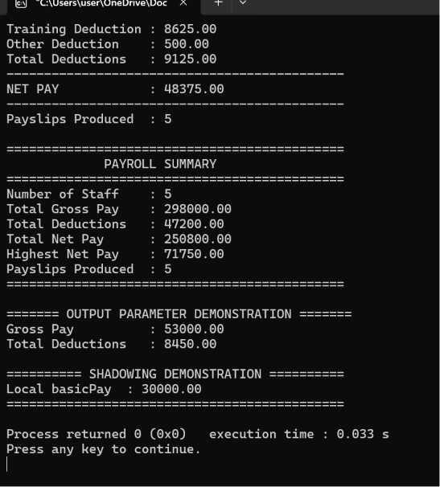
Variable Name | Type | Scope | Lifetime
staffID | int | Struct field | Lifetime of struct object
grossPay | double | Local in functions | Until function returns
payslipsProduced | static int | Local in printPayslip | Entire program execution
basicPay (global) | double | Global | Entire program execution
basicPay (local) | double | Local in demonstrateShadowing | Until block ends
TAKEAWAYS
- Static type binding: All declared variables (double, int, char[]) are bound at compile time.
-Type inference (auto): Used in calculateGrossPay and calculateNetPay for local variables.
- Parameter scope/lifetime: Formal parameters in functions like calculateTrainingDeduction exist only during function execution.
- Static locals: payslipsProduced persists across multiple calls to printPayslip.
- Shadowing: Local basicPay inside demonstrateShadowing hides the global basicPay.

Q1. At what point is this variable bound to its type?
Ex:
double gross;
The variable gross is explicitly bound to the type double at compile time when the declaration is processed demonstrating static type binding.
"When is it bound to its storage?"
For an ordinary variable such as double gross;:
Its storage is allocated when the function invocation creates its local variables.
"When is it bound to its current value?"
For gross = calculateGross(staff);, the value is bound/assigned when that statement executes at runtime.
Type → compile time
Storage → function execution
Value → assignment during execution
Q2. Where is this name visible?
Using void calculateTrainingDeduction(double grossPay)
{
...
} as an example,
grossPay is visible inside calculateTrainingDeduction() but It isn't visible in main() because it is a parameter with local scope.
The name grossPay has function scope and cannot be directly accessed outside the function where it is declared.
Q3. When does this variable begin and end its lifetime?
For an ordinary local double gross;
Its lifetime begins when the function invocation creates the local variable and ends when the function returns.
However, for static int payslipCount = 0;
Scope - printPayslip()
Lifetime - entire execution of the program
Q4. Which two names in your program are aliases?
We have:
double grossResult; double netResult; and void calculateResults(
const Staff *staff,
double *grossOutput,
double *netOutput)
Inside the function
Relationship is:
grossOutput → grossResult netOutput → netResult
Therefore, grossOutput provides access to the same storage location as grossResult, while netOutput provides access to the same storage location as netResult. This allows the function to modify the caller's variables.
Q5. Identify an I-value and r-value
If we have gross = calculateGross(staff); then:
L-value – gross (It identifies a storage location that can receive a value.
)
R-value - calculateGross(staff)(It produces the value that gets assigned.)
Q6. If this local declaration were removed, which outer declaration would be found next?
The code has: double basicPay = staff->basicPay;
{
double basicPay = 99999.00; printf("%.2f", basicPay);
}
The compiler finds the inner declaration first, which shadows the outer one.
If it is removed, the compiler will use the outer declaration
Name resolution searches the nearest enclosing lexical scope first known as static scoping
Q7. What would change with dynamic scoping?
Under static scoping:
The meaning of a variable name is determined by the program's textual structure.
Under dynamic scoping:
The meaning could depend on the chain of functions that called the current function.
So, with dynamic scoping, determining which variable a name refers to could depend on which function called which function at runtime, rather than where the variable appears in the source code.
Q8. Why is a named constant better?
We write '#define OTHER_DEDUCTION 500.0' instead of writing 500.00 repeatedly
This is better because:
- It gives the value a meaningful name.
- It avoids inconsistent values.
- It makes changes easier.
- It makes the program easier to understand.
- It clearly identifies the value as a fixed policy value.

